Copeland Wellness Service
Social Prescribing

Social prescribing Link Workers are there to help and support patients over 18 years old within Copeland. They can help link you to different services, support, activities and various other opportunities in the local area.

They can help you with:
- mild depression, anxiety or stress
- if you feel socially isolated
- have issues with their finances or debt
- family/relationship issues
- having issues with their home but NOT homelessness
- need support with bereavement after losing a loved one

The link workers can help you become motivated, independent and help to improve your health and well-being.

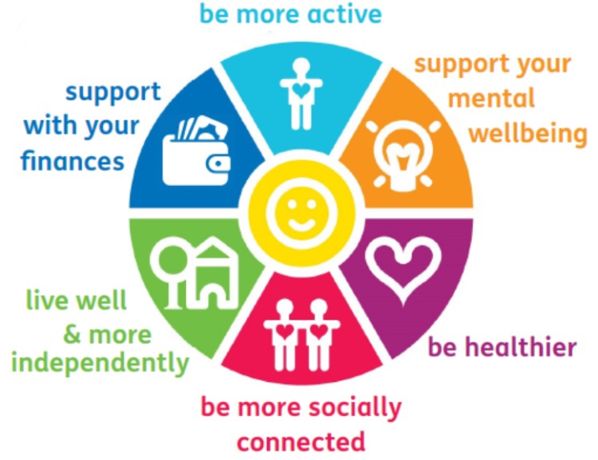

Referrals can be made by any member of staff within your surgery to the link workers, Rachel Finley, Chantell Barnes & Greg Savage by sending an email to the address below. Please include the patients name, DOB and brief explanation of why they need support.

cuccg.copelandsp@nhs.net

If you would like more information or are unsure if they can help your patient please call 07557 134652

